REPORT
M. Abdullah Siddiqui 23I-0617
Moiz Ansari 23I-0523
VOTING SYSTEM
Digital Logic Design - Lab

Contents
Project Statement 2
Solution Approach 2
Apparatus Required 3
Data Lines Input & Block Diagram 4
Proteus Implementation (Circuit Diagram) 5
Proteus Simulation (Votes < 3) 5
Proteus Simulation (Votes >= 3) 6
Flowchart of The Entire Solution 6
Hardware Simulation (Votes >= 3) 7
Hardware Simulation (Votes < 3) 7

Project Statement
A Voting System based on five inputs, each representing a vote. This system decides whether an individual wins based on the number of votes or not. 3 or more votes means the person “wins” whereas less than 3 votes represent “lose”. Win or lose is represented by the means of LED bulbs of different colors.

Solution Approach
There will be 5 inputs, namely A, B, C, D, E. Whenever any three or more of the inputs is 1, the output will be 1. Less than three 1s’ will result in output 0. From this we can construct a truth table for this problem:
A | B | C | D | E | F
0 | 0 | 0 | 0 | 0 | 0
0 | 0 | 0 | 0 | 1 | 0
0 | 0 | 0 | 1 | 0 | 0
0 | 0 | 0 | 1 | 1 | 0
0 | 0 | 1 | 0 | 0 | 0
0 | 0 | 1 | 0 | 1 | 0
0 | 0 | 1 | 1 | 0 | 0
0 | 0 | 1 | 1 | 1 | 1
0 | 1 | 0 | 0 | 0 | 0
0 | 1 | 0 | 0 | 1 | 0
0 | 1 | 0 | 1 | 0 | 0
0 | 1 | 0 | 1 | 1 | 1
0 | 1 | 1 | 0 | 0 | 0
0 | 1 | 1 | 0 | 1 | 1
0 | 1 | 1 | 1 | 0 | 1
0 | 1 | 1 | 1 | 1 | 1
1 | 0 | 0 | 0 | 0 | 0
1 | 0 | 0 | 0 | 1 | 0
1 | 0 | 0 | 1 | 0 | 0
1 | 0 | 0 | 1 | 1 | 1
1 | 0 | 1 | 0 | 0 | 0
1 | 0 | 1 | 0 | 1 | 1
1 | 0 | 1 | 1 | 0 | 1
1 | 0 | 1 | 1 | 1 | 1
1 | 1 | 0 | 0 | 0 | 0
1 | 1 | 0 | 0 | 1 | 1
1 | 1 | 0 | 1 | 0 | 1
1 | 1 | 0 | 1 | 1 | 1
1 | 1 | 1 | 0 | 0 | 1
1 | 1 | 1 | 0 | 1 | 1
1 | 1 | 1 | 1 | 0 | 1
1 | 1 | 1 | 1 | 1 | 1

Now in order to decide the further implementation, it is important to note the pattern in the table. The nature of the truth table makes its solution easier through the use of multiplexer.
After dividing the truth table into 7 parts, a pattern can be easily observed. The inputs A, B, and C will act as select lines as they range from 0 to 7 in binary. Further D & E will decide the input of the data lines based on the select input which will be represented on the output.

Apparatus Required
- Multiplexer (8-to-1)
- 2 input AND Gate
- 2 input OR Gate
- Wires
- Push Buttons
- Battery
- Resistors
- LED Light

Data Lines Input & Block Diagram

In the above block diagram, A, B, & C are applied on select lines. On the other hand, D & E are applied on data lines according to the truth table values of output. For instance:
D
E
F
EN
A B C
8 x 1 Multiplexer
A | B | C | D | E | F
0 | 0 | 0 | 0 | 0 | 0
0 | 0 | 0 | 0 | 1 | 0
0 | 0 | 0 | 1 | 0 | 0
0 | 0 | 0 | 1 | 1 | 0

For the above scenario, select lines will select 0 and no matter what the value of D & E is, it will output 0. So, on Data Line number 0, we will provide 0 as input. Similarly, for D1, D2 & D4, we will provide D AND E as input. For D3, D5 & D6, D OR E as input. For D7, 1 will be provided as input.

Proteus Implementation (Circuit Diagram)
On proteus, the above decided solution was implemented using 1x AND, 1x OR and 1x 8 to 1 multiplexer, Logic probes and Logic states.
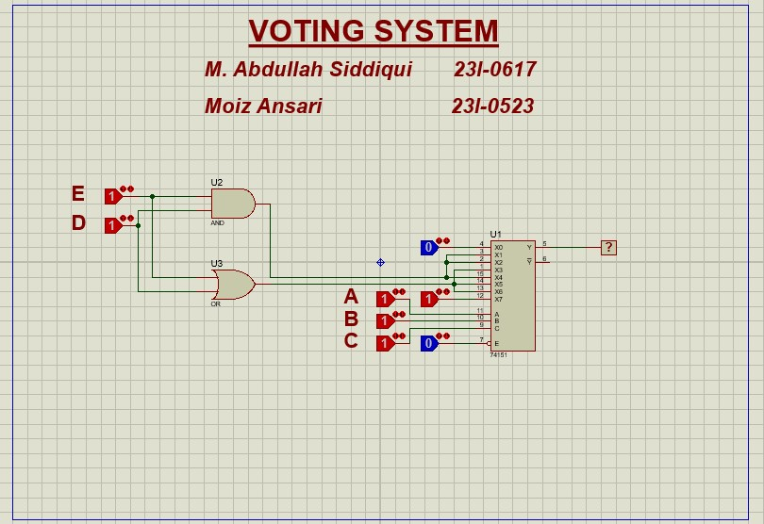

Proteus Simulation (Votes < 3)
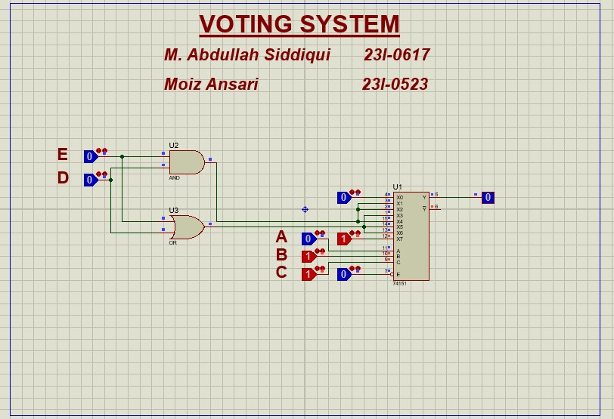
The output of the simulation is shown for votes less than 3.

Proteus Simulation (Votes >= 3)
The output of the simulation is shown for votes greater or equal to 3.

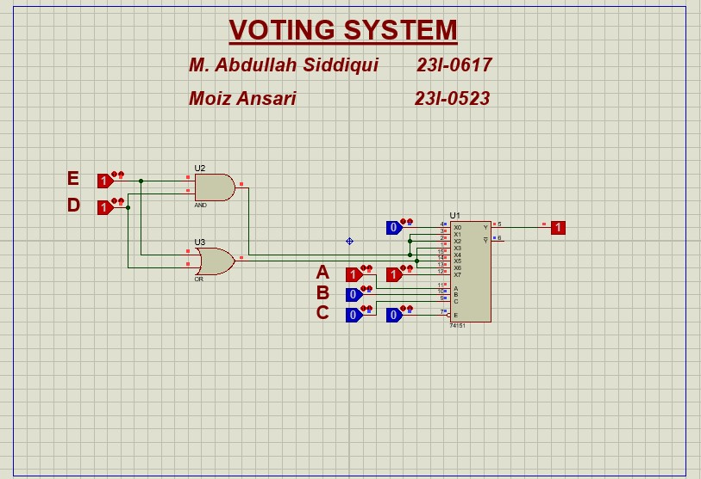
Flowchart of The Entire Solution
Hardware Implementation
Proteus Implementation
Optimized Solution
Possible Solutions
Truth Table
Problem: Voting System

Hardware Simulation (Votes >= 3)
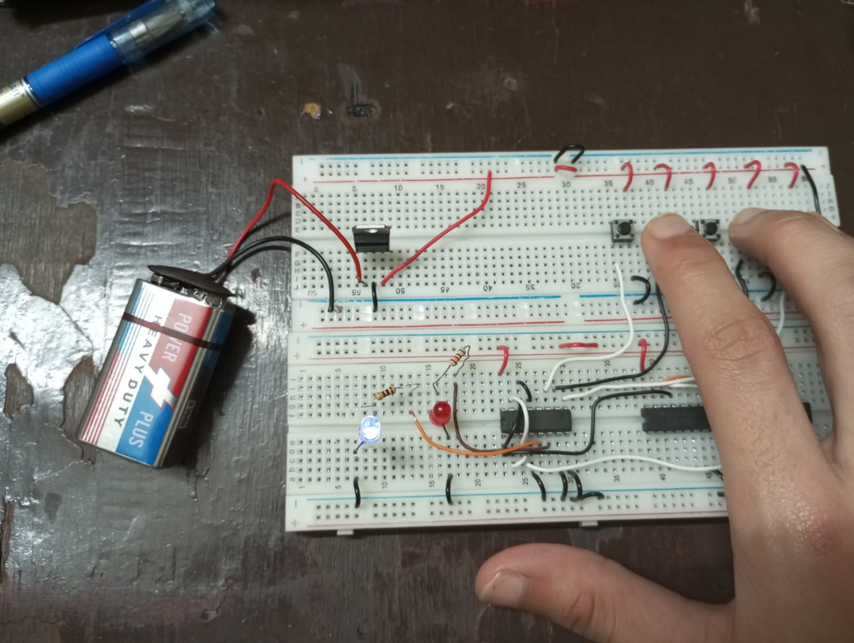

Hardware Simulation (Votes < 3)
